MO/MHC Alumni Present |  |  | Friday, September 14, 2018
YOU CAN HELP THE CHILDREN!!
Mill Creek Golf Course  1700 St. Andrews Dr.  Mebane, NC  Fri. Sept 14, 2018  4th Annual Alumni Fundraiser |  | By the time Austin was referred to Methodist Home for Children, he was arrogant and disrespectful toward authority figures. Like many teens, he didn’t see the problem at first. But the structure of the home appealed to him and he began to appreciate the skills he was learning, like asking for and accepting feedback. He also began to think about the decisions he’d made
Tee Time: 9 AM  Registration: 8 AM  Enjoy a great day raising money for a great cause! Range balls, 18 holes of golf (including cart), lunch, cold beverages, goody bags and plenty of door prizes -- all for just $75 per player or $300 per team of 4.  Hole sponsorships are $100.  The MO/MHC Alumni Association is a nonprofit, 501(c)(3) organization. Members have experienced for themselves the life-changing work done by Methodist Home for Children!  For more info and/or to register, call or email Joe Pearce at 336-213-6555; pearcejosh65@gmail.com  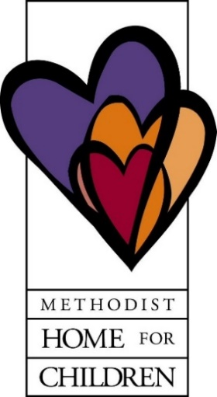 |  | and the choices that would have been better.  Austin says he’s thankful that his court counselor helped steer him to MHC’s multi-purpose home and back toward his dreams. “He didn’t want me in a Youth Development Center or in prison,” he says. “He wants me to have a good life and I realize now that he put me in here for a reason. He wants to see me doing something better with my life.”  Joanne suffered repeated physical and sexual abuse from a family member and worried she could never find a “normal,” safe home until coming into care with MHC. Her foster mom, trained and supported by experienced MHC staff, brought Joanne the stability, compassion and patient care that children with traumatic pasts need to heal and grow into their full potential.  Her foster mom says that she didn’t set out to adopt a teenage girl with an abusive past. “But God had a different plan,” she states, “and I see now this path is such a beautiful thing for the two of us. Joanne is very happy today, like a completely different child. She really has blossomed.”  To learn more about the programs of Methodist Home for Children, go to: www.mhfc.org  To download a player registration form,  go to: www.mo-mhcalumniassoc.org  Player/Team/Hole Sponsors:  Name(s) _______________________________  Contact Person: _________________________  Telephone and/or email : __________________  Please send business logo and information that you want on the sign to the address below or email to: pearcejosh65@gmail.com  Make check payable to: MO/MHC Alumni Association  Mail to: 650 Huntingdon Street, Elon, NC 27244

